UCS 1611 - Internet Programming Lab **Exercise 6: Autocomplete feature using Ajax**

**Swetha Saseendran**

**CSE-C**

**185001183**

**Learning objective:**

To develop an AJAX program that implements the Autocomplete feature for filling country names.

**Code**

**index.html**

<html>

    <head>

        <link rel="stylesheet" href="style.css">

    </head>

    <body>

        <div align=center style="padding-top: 15%;">

            <h1>Country Database</h1>

            <form autocomplete="off">

              <div class="autocomplete" style="width:300px;">

                  <input type="text" id="country"  list="countries" onkeyup="getCountry()" placeholder="Search for country name" />

                  <datalist id ="countries" >

              </div>

              <input type="submit" onclick="wiki_redirect(event)">

            </form>

        </div>

        <script>

*function* fetch(*country*)

            {

*var* request = new XMLHttpRequest();

*var* URL = "country?country="+*country*;

              request.onreadystatechange = *function*()

              {

                if(this.readyState == 4 && this.status == 200)

                {

*var* val = request.responseText;

                  console.log(val)

                  document.getElementById("countries").innerHTML = val;

                }

              };

              request.open('GET', URL, true);

              request.send();

            }

*function* getCountry()

            {

*var* country = document.getElementById("country").value;

              fetch(country);

            }

*function* wiki_redirect(*event*)

            {

*event*.preventDefault()

*var* c = document.getElementById("country").value

              window.location.replace("https://en.wikipedia.org/wiki/"+c)

            }

        </script>

    </body>

</html>

**style.css**

* {

*box-sizing*: border-box;

}

body

{

*font-family*: 'Source Sans Pro', sans-serif;

*font-size*: 100%;

*background*: url(*bg.jpg*)no-repeat center top;

*background-size*: cover;

*background-position*: center;

}

h1

{

*font-size*: 4vw;

*margin*: 3.5vw 0vw 2vw;

*font-weight*: 300;

*color*: #fff;

*text-shadow*: 3px 3px 3px #1d1d1d;

*letter-spacing*: 5px;

*text-align*: center;

*font-family*: 'Source Sans Pro', sans-serif;

}

/*the container must be positioned relative:*/

.autocomplete {

*position*: relative;

*display*: inline-block;

}

input {

*border*: 1px solid transparent;

*background-color*: #f1f1f1;

*padding*: 10px;

*font-size*: 16px;

}

input[type=text] {

*background-color*: #f1f1f1;

*width*: 100%;

}

input[type=submit] {

*background-color*: DodgerBlue;

*color*: #fff;

*cursor*: pointer;

}

.autocomplete-items {

*position*: absolute;

*border*: 1px solid #d4d4d4;

*border-bottom*: none;

*border-top*: none;

*z-index*: 99;

  /*position the autocomplete items to be the same width as the container:*/

*top*: 100%;

*left*: 0;

*right*: 0;

}

.autocomplete-items div {

*padding*: 10px;

*cursor*: pointer;

*background-color*: #fff;

*border-bottom*: 1px solid #d4d4d4;

}

/*when hovering an item:*/

.autocomplete-items div:hover {

*background-color*: #e9e9e9;

}

/*when navigating through the items using the arrow keys:*/

.autocomplete-active {

*background-color*: DodgerBlue !important;

*color*: #ffffff;

}

**country.java**

import java.io.*;

import jakarta.servlet.*;

import jakarta.servlet.http.*;

import java.sql.*;

import java.util.*;

//javac -d WEB-INF/classes country.java

public class country extends *HttpServlet*

{

  public *void* doGet(*HttpServletRequest* *request*, *HttpServletResponse* *response*) throws *ServletException*, *IOException*

  {

*String* JDBC_DRIVER = "com.mysql.jdbc.Driver";

*String* DB_URL= "jdbc:mysql://localhost:3306/autocomplete";

*String* USER ="root";

*String* PASS="mysql";

    try

    {

      response.setContentType("text/html");

*PrintWriter* pw = response.getWriter();

*Connection* conn = DriverManager.getConnection(DB_URL,USER,PASS);

*String* country_name = request.getParameter("country");

*String* search = "SELECT `country_name` FROM `countries` WHERE `country_name` like '"+country_name+"%' ;";

*Statement* stmt = conn.createStatement();

*ResultSet* rs = stmt.executeQuery(search);

      while(rs.next())

      {

*String* country = rs.getString("country_name");

        pw.println("<option name='"+country+"'>"+country+"</option>");

      }

    }

    catch(*Exception* *E*)

    {

      E.printStackTrace();

    }

  }

}

**web.xml**

<web-app>

    <servlet>

        <servlet-name>country</servlet-name>

        <servlet-class>country</servlet-class>

    </servlet>

    <servlet-mapping>

        <servlet-name>country</servlet-name>

        <url-pattern>/country</url-pattern>

    </servlet-mapping>

</web-app>

**OUTPUTS:**

When the user types the first letter:

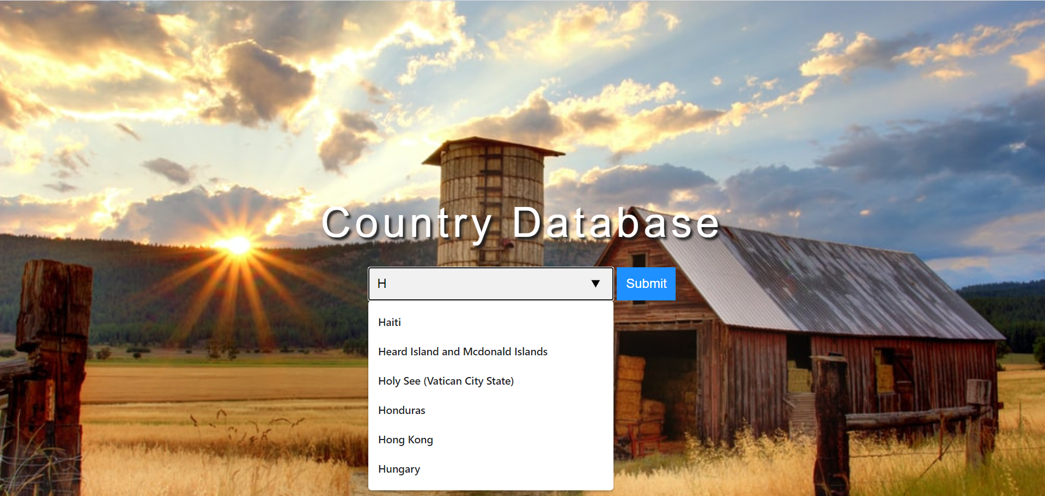

When subsequent letters are typed:

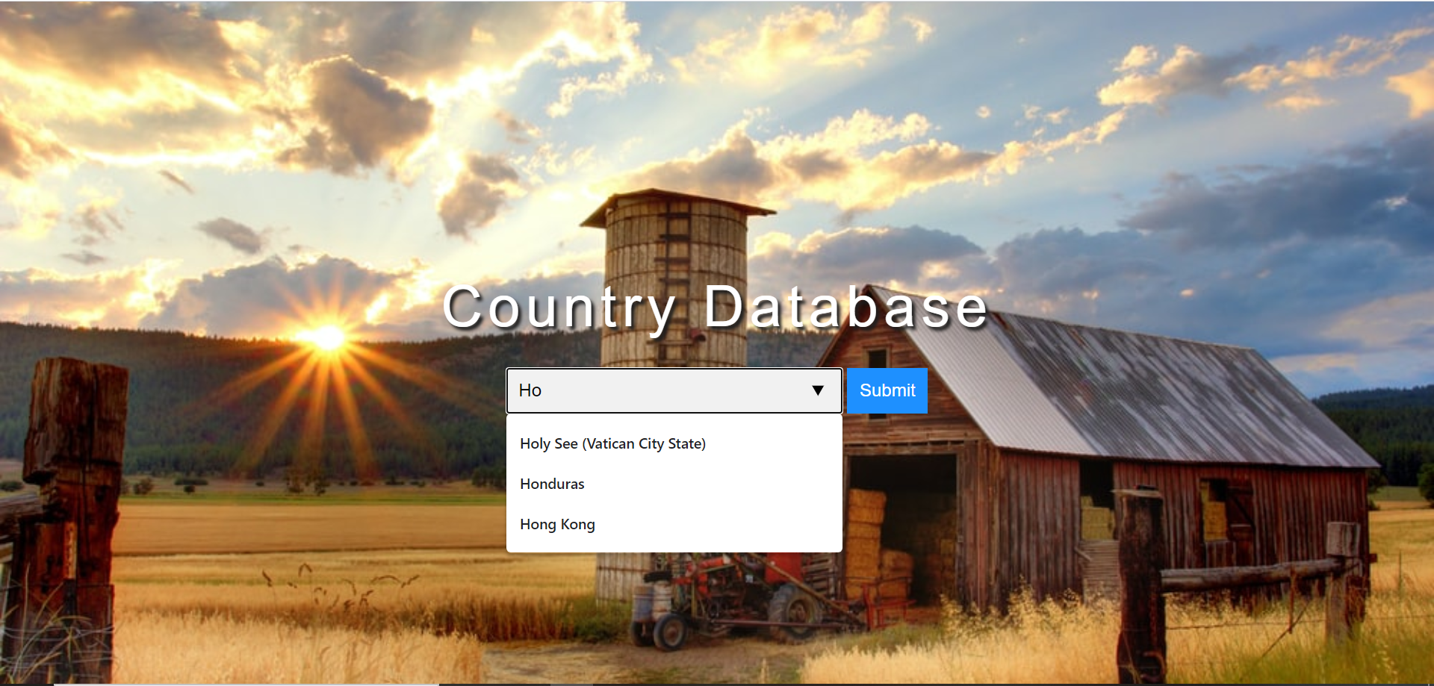

Highlight on hovering over the options:

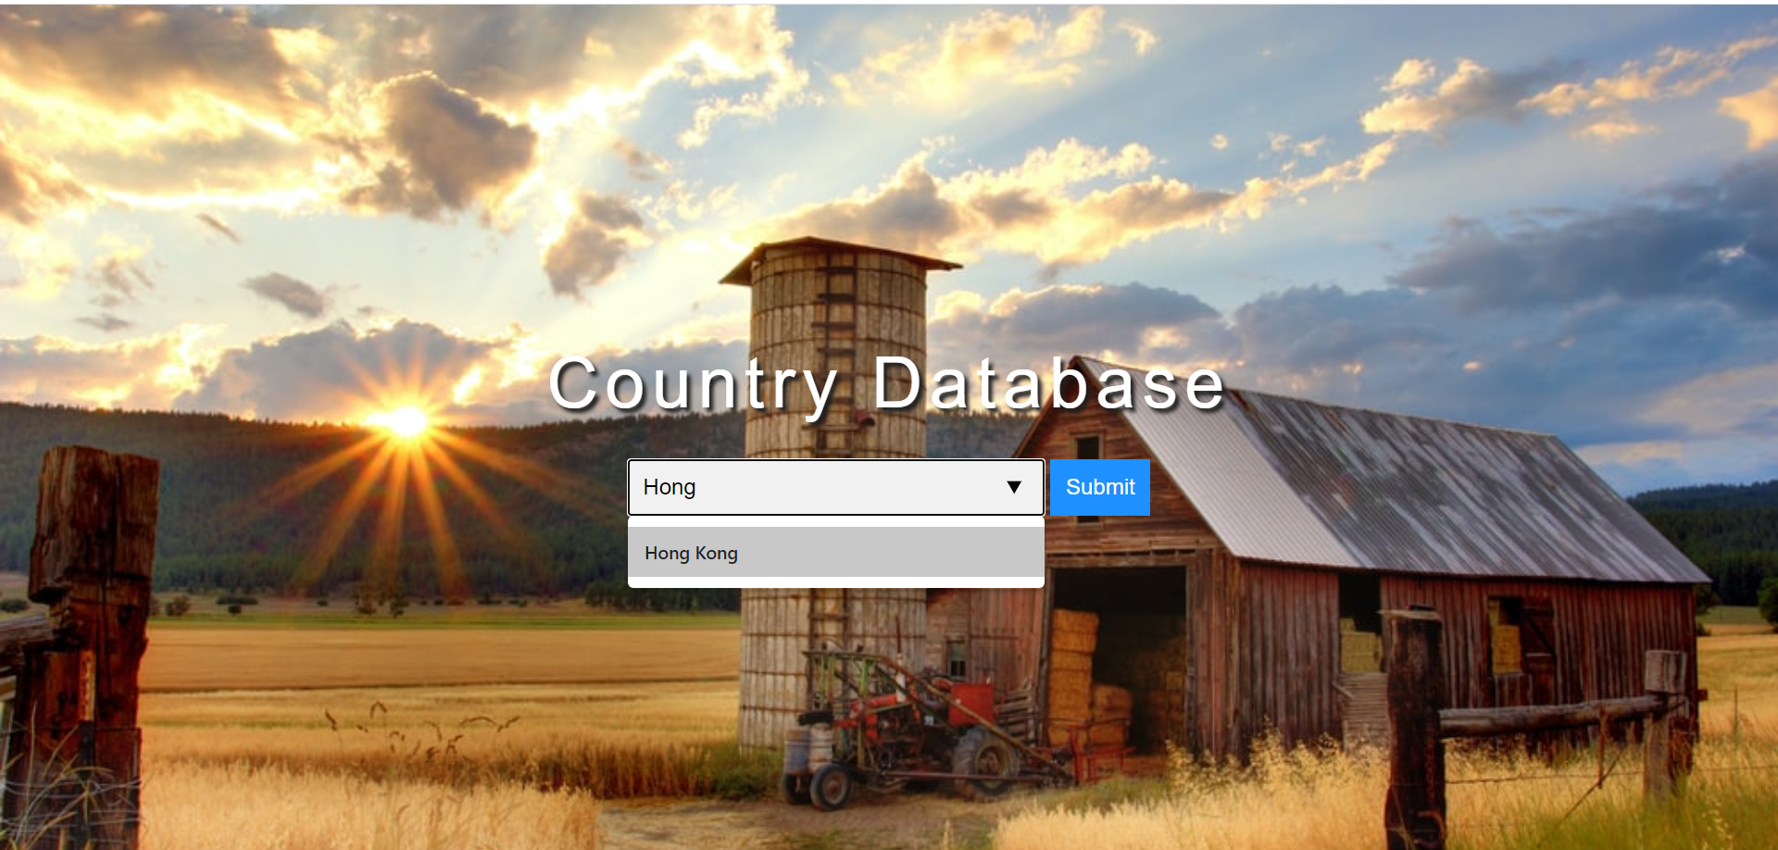

On submission the corresponding Wikipedia page of the country is rendered:

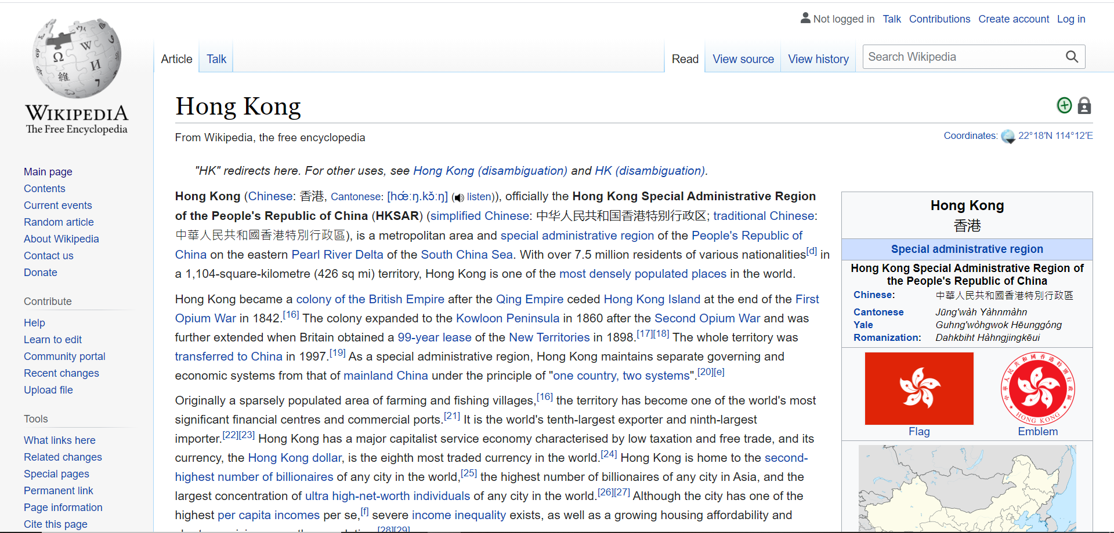

**MySQL Database:**

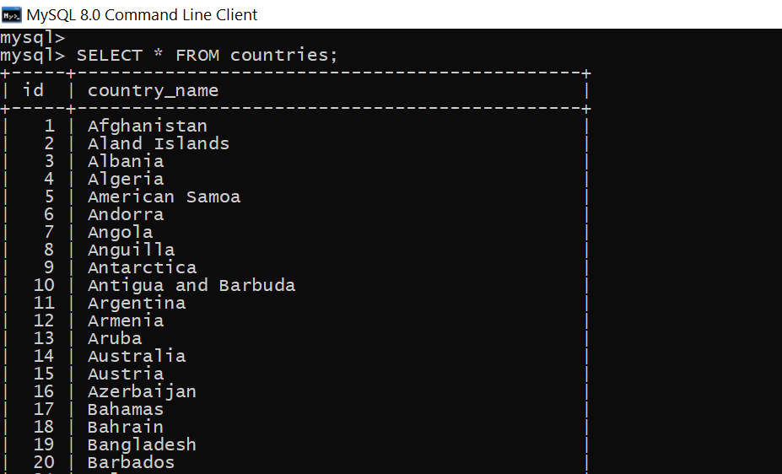

**LEARNING OUTCOME:**

* Understood that the XMLHttpRequest object can be used to exchange data with a server behind the scenes and thus we can update parts of a web page, without reloading the whole page.
* Learnt how to use Ajax technique to invoke back end servlet, get the response from servlet and modify the user interface accordingly.
* Understood that servlets are used to process a request of Ajax to the server, manage state for the client, access data resources, and generate the XML for the response.
* Learnt to write query for relational data, and parse result using SQL actions.
* Understood how to dynamically retrieve data from SQL and render the country names as the user types in each character.
* Understood the importance of dynamic making web pages using Ajax as they well-formed and user friendly.